**PGM Assignment 4**

**BN Parameter Learning**

11:59 pm, Nov. 11thh

Given the discrete Bayesian Network below and it’s training data,

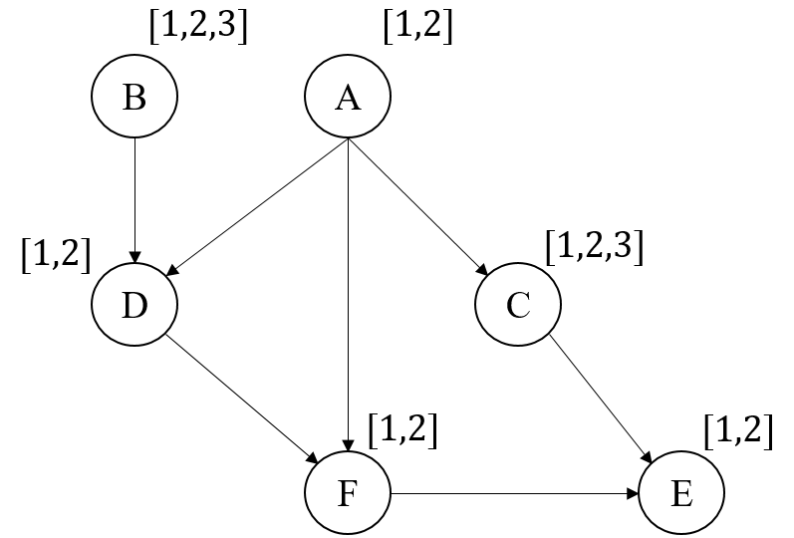

Node B and Node C have three possible states (1,2, or 3). Other four nodes are binary (1 or 2).

Perform the following tasks:

1. Obtain the training data from the attached file and read the README first.
2. Perform BN parameter learning using the maximum likelihood estimation (MLE) method. For 6000 level students, also perform the BN parameter learning using the maximum posterior probability (MAP) method. For MAP learning, use different prior hyper-parameters as determined by by varying the  value. Note select   to ensure njk + Nnjk >1.
3. For MLE learning method, give the learnt CPTs for each node. For the MAP learning method, show the estimated CPTs under different values of .
4. Assume the groundtruth CPTs are as follows,

Node A:

|  |  |
| --- | --- |
| P(A=1) | P(A=2) |
| 0.4 | 0.6 |

Node B:

|  |  |  |
| --- | --- | --- |
| P(B=1) | P(B=2) | P(B=3) |
| 0.3 | 0.4 | 0.3 |

Node C:

|  |  |  |  |
| --- | --- | --- | --- |
| A | P(C=1) | P(C=2) | P(C=3) |
| A=1 | 0.3 | 0.25 | 0.45 |
| A=2 | 0.05 | 0.2 | 0.75 |

Node D:

|  |  |  |
| --- | --- | --- |
| A B | P(D=1) | P(D=2) |
| 1 1 | 0.05 | 0.95 |
| 2 1 | 0.22 | 0.78 |
| 1 2 | 0.93 | 0.07 |
| 2 2 | 0.53 | 0.47 |
| 1 3 | 0.41 | 0.59 |
| 2 3 | 0.3 | 0.7 |

Node E:

|  |  |  |
| --- | --- | --- |
| C F | P(E=1) | P(E=2) |
| 1 1 | 0.02 | 0.98 |
| 2 1 | 0.3 | 0.7 |
| 3 1 | 0.13 | 0.87 |
| 1 2 | 0.32 | 0.68 |
| 2 2 | 0.92 | 0.08 |
| 3 2 | 0.58 | 0.42 |

Node F:

|  |  |  |
| --- | --- | --- |
| A D | P(F=1) | P(F=2) |
| 1 1 | 0.95 | 0.05 |
| 2 1 | 0.43 | 0.57 |
| 1 2 | 0.1 | 0.9 |
| 2 2 | 0.28 | 0.72 |

Plot both the MLE and MAP learning methods in terms of KL divergence between the estimated distribution and the groundtruth distribution versus the number of training samples as the plot in the lecture notes.

1. Write up a report that summarizes the MLE and Bayesian learning theories and the key equations for learning the two models and discuss the experimental results.
2. Submit your report and code to your box folder.

Note write your own code to perform each task; do not use others’ software to perform the tasks.